**Qut:** Journal of Religion, Philosophy and Culture, 1(1), 2025:

ISSN: 3105-4153

DOI:

*Article*

**TITLE**

**First author** 1 , **Second author** 2,\*



1First author’s affiliation, city, country

2Second author’s affiliation, city, country

\*e-mail: (the email address of the corresponding author)

**Abstract**

An abstract is a concise summary of the article. It should be written as a single paragraph and not exceed 150–200 words. The abstract must be clear and include four aspects of logical justification: the importance of the study, the approaches or methods used, the results of the research, and the conclusion.

**Keywords:** Keywords should be written below the abstract and separated by semicolons (5 to 7 words).

**Атауы**

**Аңдатпа**

Аңдатпа – мақаланың қысқаша мазмұны. Ол бір абзац түрінде жазылады және 150–200 сөзден аспауы тиіс. Аңдатпа қарапайым жазылып, логикалық негіздеудің төрт аспектісін қамтуы қажет: зерттеудің маңыздылығы, қолданылған тәсілдер немесе әдістер, зерттеу нәтижесі және қорытынды.

**Түйін сөздер:** Түйінді сөздер аңдатпаның астына жазылуы керек және нүктелі үтірмен ажыратылады (3-тен 5 сөзге дейін).

**Название**

**Аннотация**

Аннотация представляет собой краткое изложение статьи. Она пишется одним абзацем с одним интервалом и не должна превышать 150–200 слов. Аннотация должна быть простой и содержать четыре аспекта логического обоснования: важность исследования, использованные подходы или методы, результат исследования и заключение.

**Ключевые слова:** Ключевые слова должны быть написаны под аннотацией и разделены точкой с запятой (от 5 до 7 слов).

**Introduction**

The introduction includes the background, literature review, originality of the work, and the research objective. It should also demonstrate the relevance and importance of the problem under consideration and position the study within the broader academic context.

**Materials and Methods**

The “Materials and Methods” section should describe the sources, data, and applied approaches. Methods must be presented in practical terms, focusing on how the data were obtained, coded, and analyzed rather than on long conceptual explanations. If necessary, authors may also clarify the choice of a specific theoretical framework.

**Results and Discussion**

In the Results and Discussion section, the main findings of the study are clearly presented and supported by relevant data (e.g., tables and graphs). These results are interpreted in the context of existing literature and compared with previous studies to highlight new insights. The discussion explains the significance of the findings and their practical and theoretical implications. Any limitations of the study are acknowledged, and directions for future research are suggested.

All illustrations should be cited in the main text as **Table 1**, **Figure 1**, etc.

**Table 1.** Table name

|  |  |  |
| --- | --- | --- |
| **Text** | **Text** | **Text** |
| Text | Text | Text |

**Figure 1.** Figure name

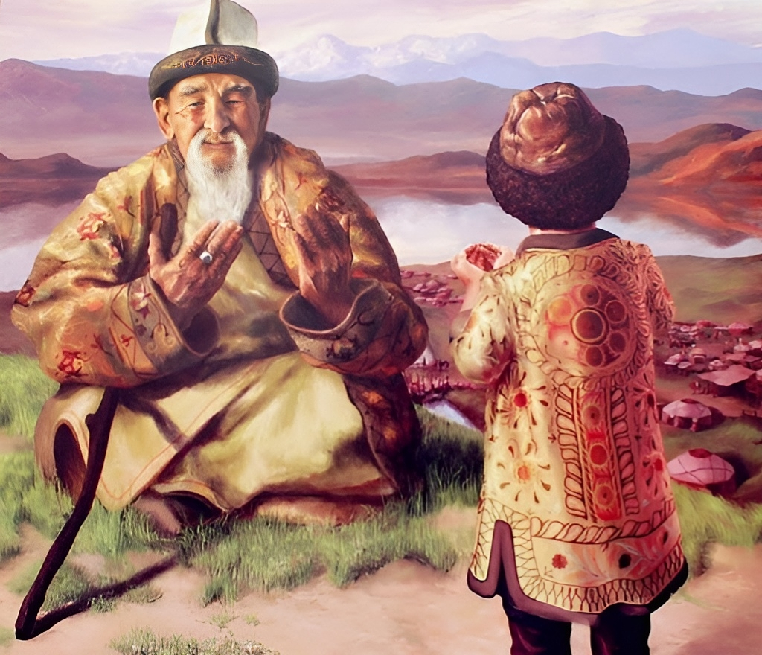

**Conclusion**

The conclusion summarizes the results of the study and formulates the main findings. It emphasizes the originality and significance of the outcomes for the advancement of academic knowledge. The conclusion may also provide practical recommendations and outline directions for future research.

**Acknowledgment / Funding**

This section is optional. Authors may indicate institutions, grant projects, research funds, or individuals who supported the study, as well as its sources of funding.

**Authors’ Contributions**

The "Authors’ Contributions" section is mandatory to clarify the role of each co-author in preparing the manuscript. Authors may indicate their involvement in developing the research concept, collecting and analyzing data, writing and revising the text, as well as providing overall supervision of the study.

First author – writing the article text, literature review, editing the text.

Second author – writing the article text, technical formatting, correspondence, submission of the article.

**Conflict of interests.**

The authors declare that there is no conflict of interest.

**References**

The reference list should follow APA 7th edition style: entries are arranged alphabetically by the surname of the first author, using a hanging indent. Detailed examples and exceptions can be found at: <https://apastyle.apa.org/style-grammar-guidelines/references/examples#textual-works>

For non-English sources, Latin transliteration ([https://translit.ru](https://translit.ru/)) is applied, and an English translation is added in square brackets. Add DOI (if available).

Abzhalov, S. A., & Zatov, K. A. (2017). Religioznyj opyt: religiovedcheskij analiz [Religious experience: Religious studies analysis]. *Vestnik KazNU. Serija filosofii, kul'turologii i politologii*, *59*(1), 37-45.

Allport, A. (presumed). (1937). *Marion Taylor today—by the biographer* [Unpublished manuscript]. Marion Taylor Papers, Schlesinger Library, Radcliffe College, Cambridge, MA, United States.

Cihan, A. K. Sühreverdî’nin Nur ve İnsan Düşüncesi. *Doğu’dan Batı’ya Düşüncenin Serüveni*, 975-990.

Gabitov, T.H. (2013). *Qazaq mәdenietіnіn ruhani kenіstіgі* [Spiritual space of Kazakh culture]. Raritet.

QMDB HALAL [@halaldamu.kz]. (2025, August 13). *«QMDB HALAL» sertifikatyn qalay alamyz?* [How do we get a"QMDB HALAL" certificate?][Photo]Instagram. <https://www.instagram.com/halaldamu.kz/p/DNV18Ehs3kT/>

Kaliyev, K., Temirbayev, T., & Toxanbayev, A. (2024). EXPLORING THE PHENOMENON OF RELIGIOUS CONVERSION AMONG KAZAKH YOUTH IN THE GLOBALIZED SOCIETY. *European Journal of Science and Theology*, *20*(6), 27-41.

Kazmukhanov, Р., Abylov, Т., Bulan J., & Kurpebayeva, G. (2025). Psychosocial characteristics of men and women visiting holy places (using the example of holy places in Southern Kazakhstan). *Eurasian Journal of Religious Studies*, *41*(1), 92–102. <https://doi.org/10.26577//EJRS20254119>.

King James Bible. (2017). King James Bible Online. <https://www.kingjamesbibleonline.org/> (Original work published 1769)

Koskina, A. (2024, December 25). *How Imams Are Trained in Kazakhstan: An Insider’s View*. Central Asian Bureau for Analytical Reporting. <https://cabar.asia/en/how-imams-are-trained-in-kazakhstan-an-insider-s-view>

Muminov, A. (2018). Sufi groups in contemporary Kazakhstan: Competition and connections with Kazakh Islamic society. In D. DeWeese & J. Gross (Eds.), *Sufism in Central Asia* (pp. 284-298). Brill. [https://doi.org/10.1163/9789004373075](https://doi.org/10.1163/9789004373075" \t "_blank)

Shagirbayev, A. D., Tursynovich, K. S., Shaikimovich, A. A., & Satershinov, B. M. (2015). Islam and modernism in Kazakhstan Mashkur zhusup’s religious views. *European Journal of Science and Theology*, *11*(4), 189-197.

Temirbayev, T., & Temirbayeva, A. (2023). Leaders of sufi groups in Kazakhstan syncretism and transformation of doctrine. *European Journal of Science and Theology*, *19*(2), 11-23.

The Qur'an(M.A.S Abdel Haleem, Trans.). (2004).  Oxford University Press.

**U.S. Department of State. (2023).** 2023 Report on International Religious Freedom: Israel, West Bank and Gaza**.**  <https://www.state.gov/reports/2023-report-on-international-religious-freedom/israel-west-bank-and-gaza/>

Yale University. (2010, April 14).Globalization of energy demand [Video]. YouTube. <http://www.youtube.com/watch?v=RJM7HLyzsCM>

Yarlykapov, A. A. (2008). *Islam u stepnyh nogajcev* [Islam among the steppe Nogais]. Institut jetnologii i antropologii im. Mikluho-Maklaja RAN.

Yarosh, O. (2017). Problemy izuchenija obrashhenija v islam v sufijskih obshhinah Zapada: sociokul'turnyj kontekst, instituty, harizma [Problems of Studying Conversion to Islam in Western Sufi Communities: socio-cultural context, institutions, charisma]. *Islamology*, *7*(1), 72-87.

***Information about authors / Авторлар туралы мәлімет / Сведения об авторах***

Name of the first author – affiliation, city, country, ORCID, e-mail.

Name of the second author – affiliation, city, country, ORCID, e-mail.

Бірінші автордың аты жөні – аффиляциясы, қаласы, елі, ORCID, e-mail.

Екінші автордың аты жөні – аффиляциясы, қаласы, елі, ORCID, e-mail.

ФИО первого автора – аффилиация, город, страна, ORCID, e-mail.

ФИО второго автора – аффилиация, город, страна, ORCID, e-mail.